Minikube Installation.

* You can enter the installation documents link

Link: <https://kubernetes.io/docs/tasks/tools/install-minikube/>

* You can run the command in your local CMD.

Command: “systeminfo”

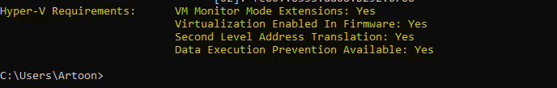

Output will be like this yellow words.

* Then Open this link: <https://kubernetes.io/docs/tasks/tools/install-minikube/>

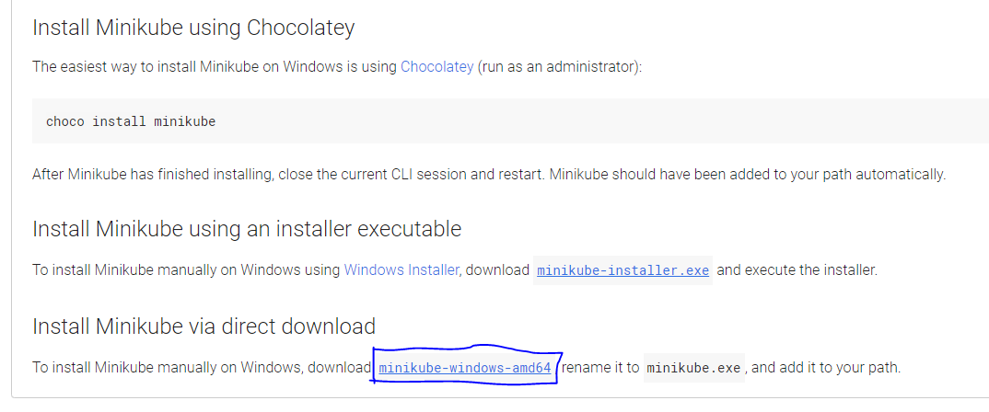

Click on blue mark box.

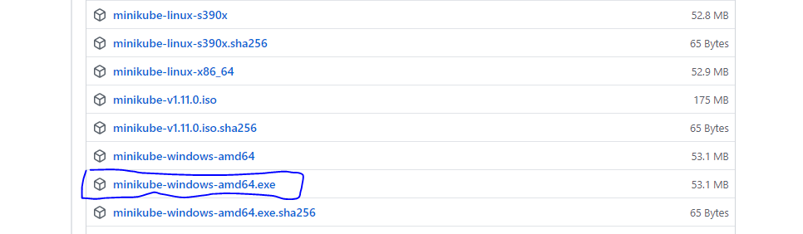

Then click on blue mark box and download it.

* Then click on blue mark box for the install kubctl.

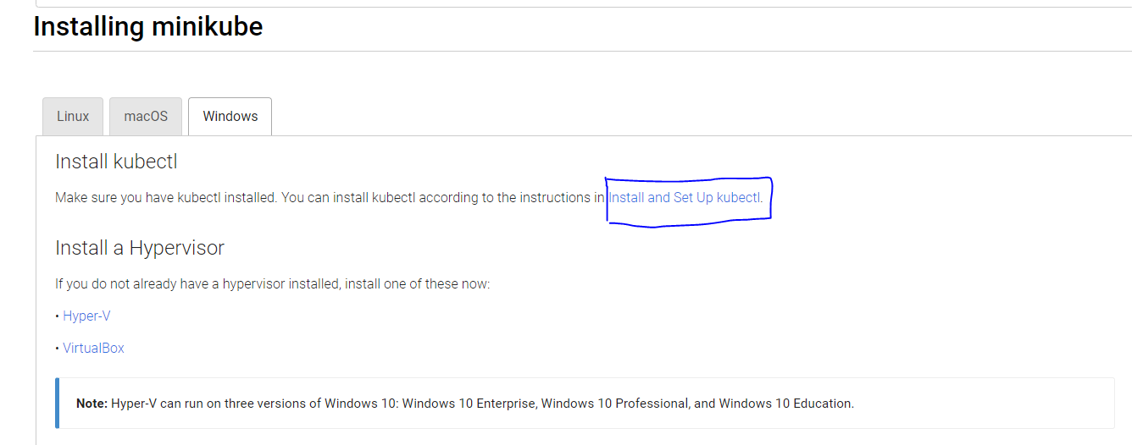

Then only yellow mark link is copy then paste on your browser and download to the kubctl.

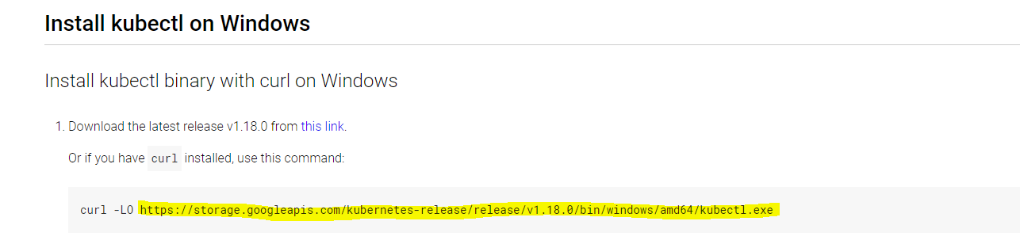

* Then two .exe file downloaded to cut and paste in ‘C’ drive and make one folder then paste in this folder.

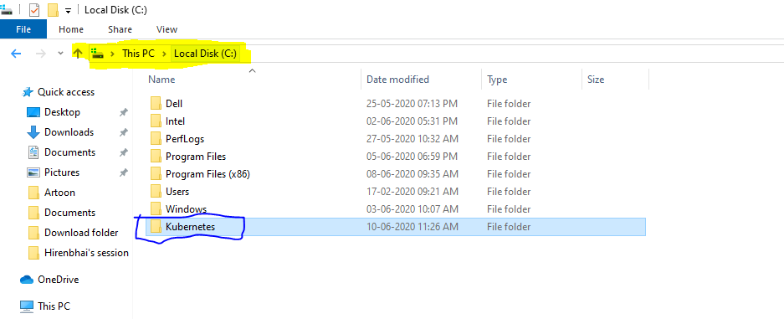

Make this folder and two .exe file will be paste in this folder.

* Then set the path of this minikub and kubectl in environment variable

Path: C:\Kubernetes

This path will paste in environment variable .

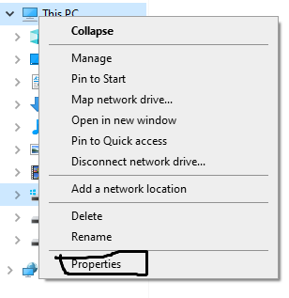

Right click on This PC and select the Properties.

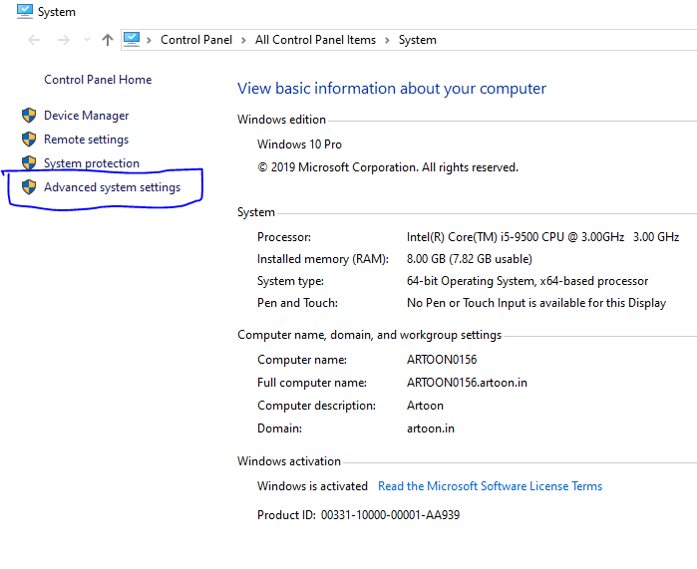

Then click on Advance system setting.

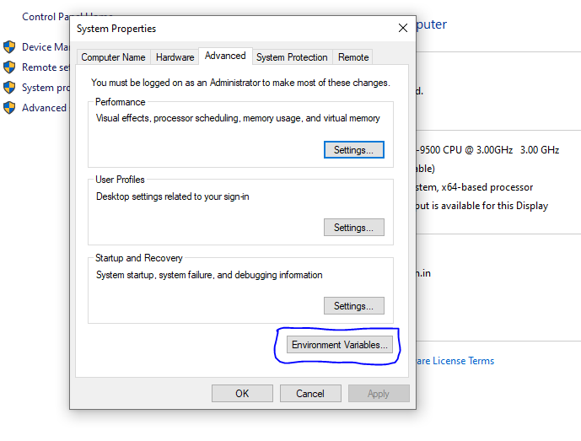

Then click on Environment variables.

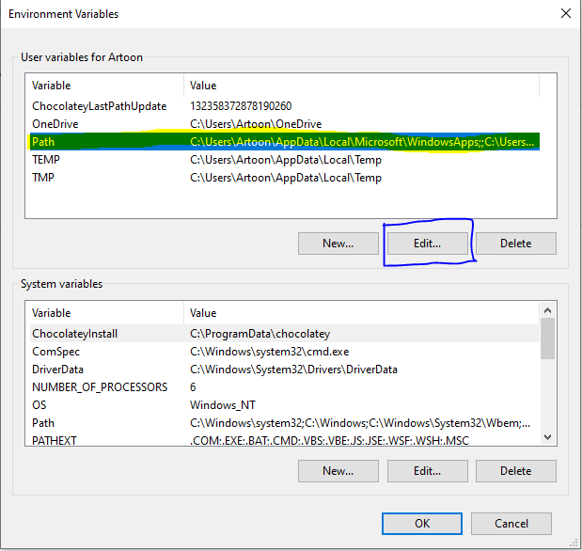

Then click on edit button and paste the path.

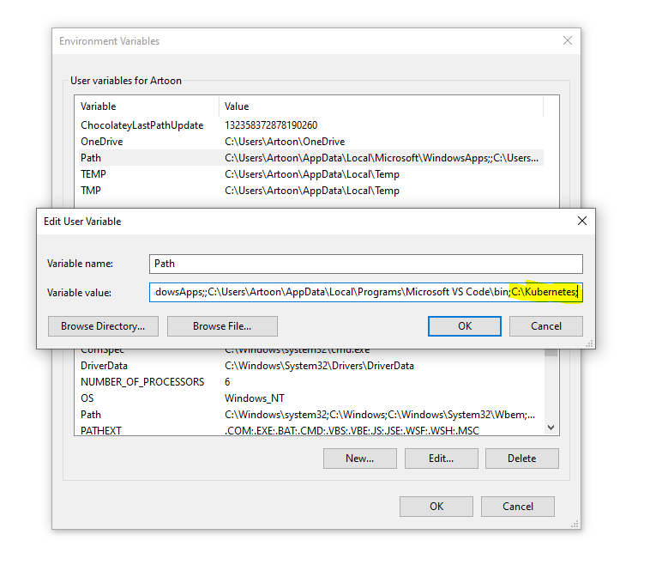

Paste my path in environment variables. Then press the OK button.

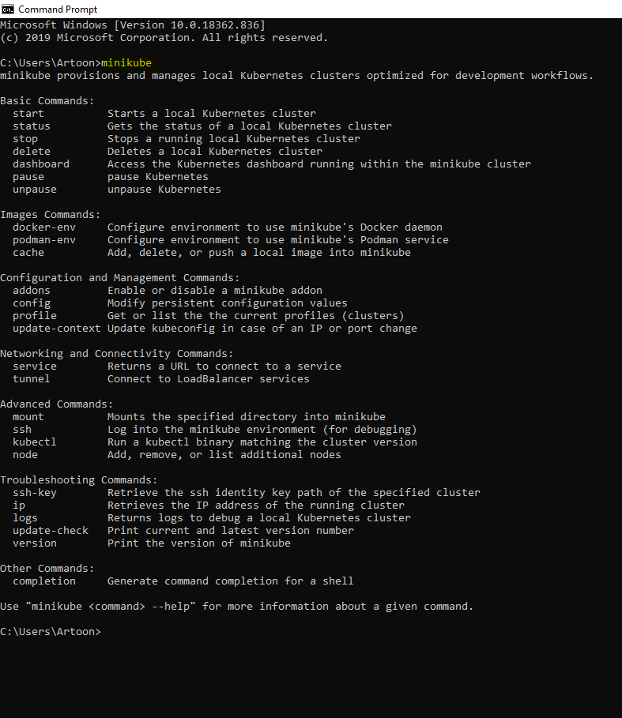

Then open the CMD and run the command ‘minikube’

* How to Dashboard create using minikube.

Command: ‘minikube dashboard’

